Welcome to edmodo, Faubion parents!

Hello Parents!

This year we will be using edmodo in my classes. edmodo is a free and secure social learning network for teachers, students and schools. It provides a safe and easy way for us to connect, share content and access homework. It looks like Facebook, but it does not incorporate any of the chat functions like Facebook.
edmodo also offers parent accounts and I invite you to join our classroom online.
With Parent Accounts, you can:
- View your child’s homework assignments and due dates
- Receive updates on class and school events
edmodo is accessible online and on any mobile device with Internet capabilities (they also offer a free iPhone and Android app). You can access your account on the go, and adjust your notification settings within edmodo to receive alerts via text or email.
To join our classroom on edmodo, follow these steps:
1. How to retrieve parent codes
Parent account codes can be retrieved from your student's account. To locate the code:
Select the teacher/class group on your student's account that you wish to get the codes for.
- On the bottom of the right margin, you will see "Give this code to your parents so they can create an Edmodo account." Then there is a code in a blue box below. This is your parent code.
2. Go to www.edmodo.com
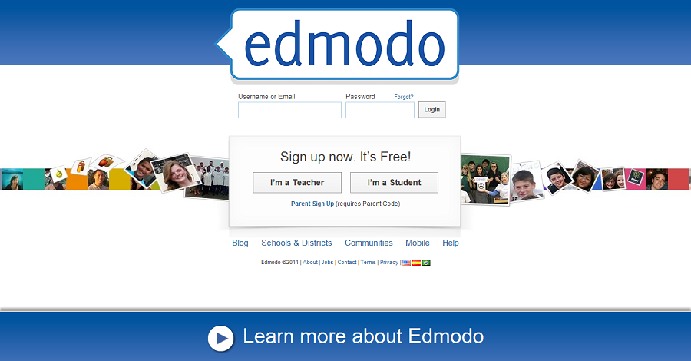
3. How to create a parent account
To create an account, parents should visit edmodo.com and select the “I’m a Parent Button” on the homepage, just below the student and teacher sign up buttons. Complete the registration form, which includes your unique parent code, your relationship with the child and a valid email address.
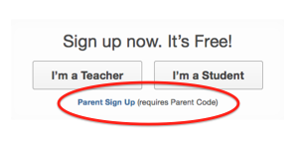
Parent account overview
Within the parent account homepage, parents can:
- Get a dashboard view of their child’s school activities including:
  - Assignments Due- A list of upcoming assignments.
  - Upcoming Events- A list of upcoming calendar notices which may include assignments, school events, tests, etc.
  - Assignment Comments- Recent teacher feedback provided on their assignments.
If a parent has multiple students on edmodo, they can add additional students to their edmodo account by selecting the “Add a Student” button on the top navigation bar. Utilizing the “Filter post by” option, the parent can also filter messages by individual child.
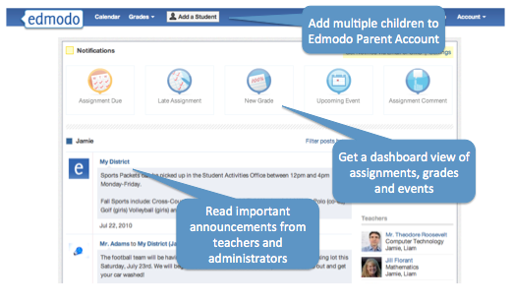
After you sign up for the first time, you will no longer need the parent code – you will log-in using your unique username and password to log-in. You will only have one parent code per student and you will not have to remember it once you have your login created.
4. Here are some more features of edmodo for Parents:

Homework Answer Keys
Classes with assigned homework can access homework answer keys. Homework is assigned to provide independent practice in preparation for in-class assessments. It is critical for each child complete their homework assignments when given. Homework specific answer keys will provide immediate feedback to each child so that any difficulties can be addressed with the teacher the following day in class.
Calendar
Within the calendar (located on the top navigation menu), a parent can see all of their student’s events, due dates, and assignments. They can filter to see a single child’s calendar by selecting the child’s name from the drop down menu located at the top right corner of the calendar. To scroll through other months, select the forward and backward arrows in the upper left corner of the calendar.
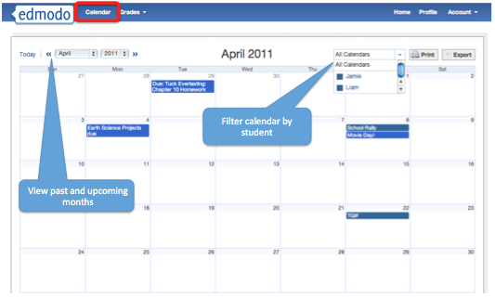
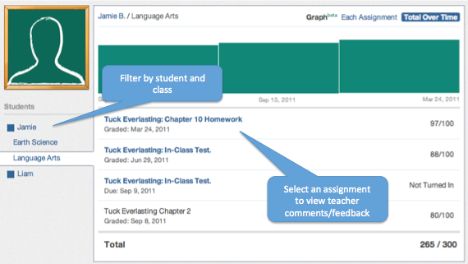
Settings
From the settings page, parents can sign up for email or text notifications that will alert them to any assignments, direct messages or alerts from teachers. Parents can also change their email address or password if needed.
To access the account settings page, select the down arrow located next to the “Account” option in the top navigation. In the drop down menu, select the “Settings” option.
Please let me know if you have any questions. I look forward to connecting with you on edmodo!
Sincerely,
John Blankenbaker, M.S.Ed.
8th Grade Mathematics and Grade 8 PreAP Algebra 1
AVID Site Team
Faubion MS

